SCV5018
ORETAN BARNABAS OLUWANISHOLA

MOVIE DATABASE MODEL QUERY

-- 1 Write a query in SQL to find the name and year of the movies.

select mov_title, mov_year
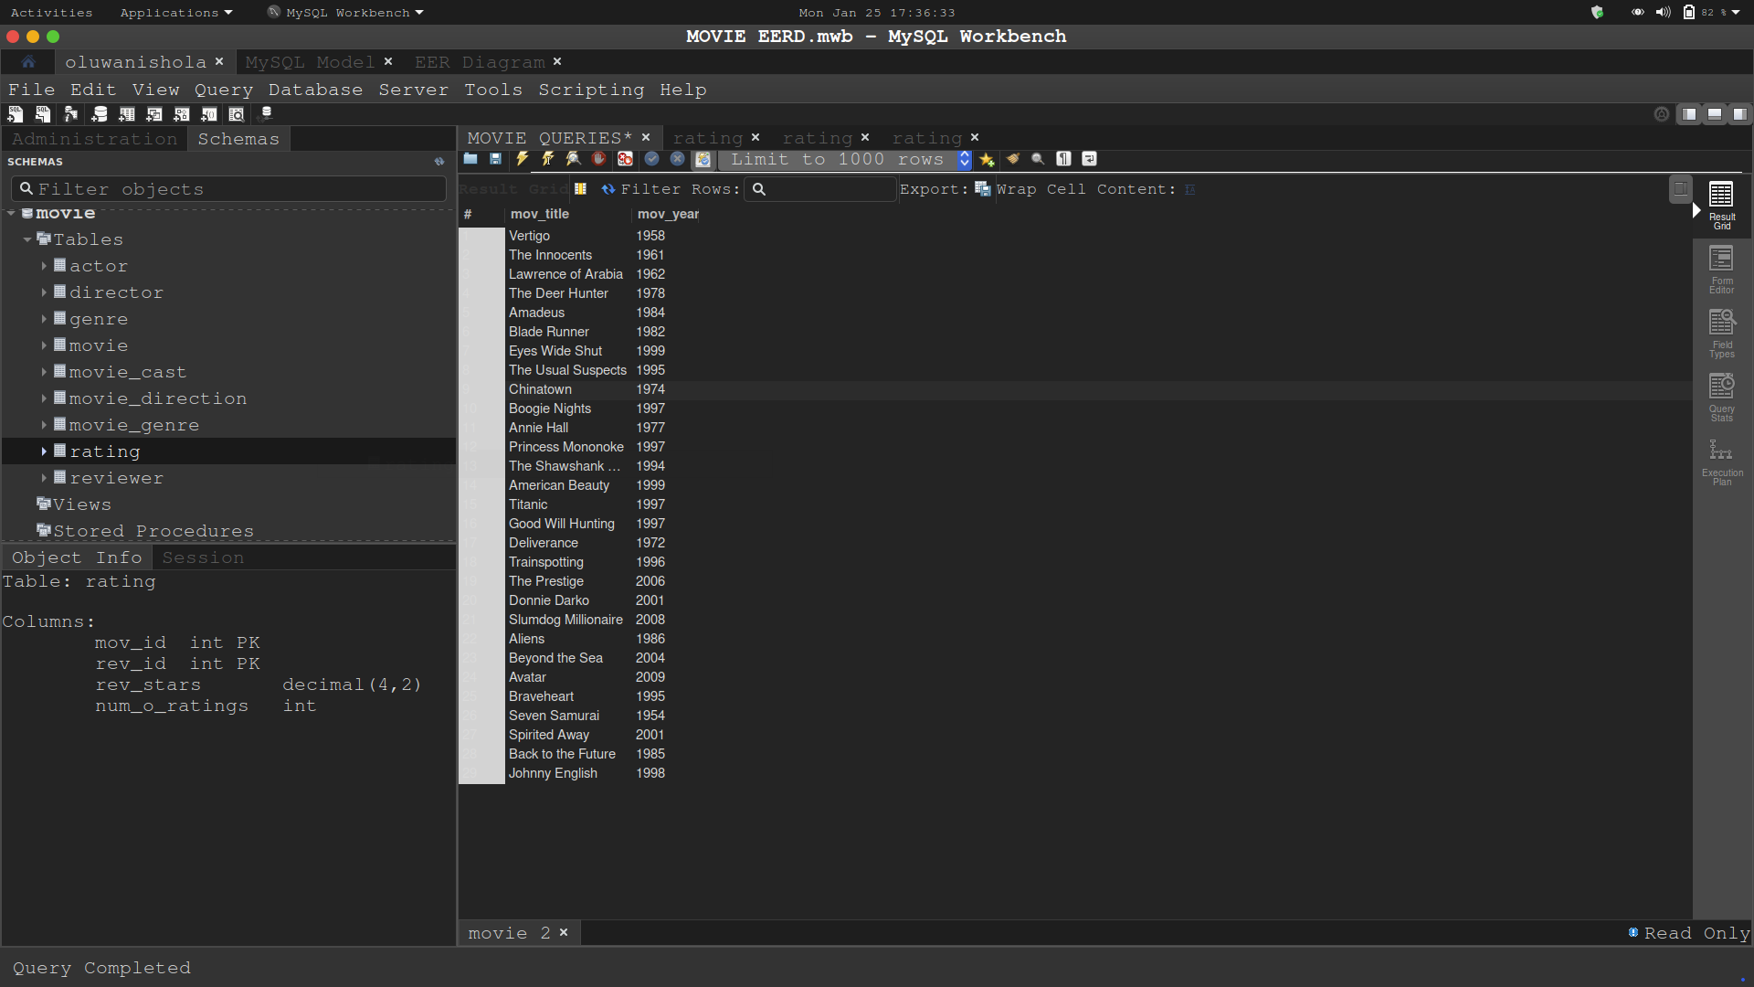
from movie;

-- 2 Write a query in SQL to find the year when the movie American Beauty released.

select mov_year, mov_title
from movie
where mov_title = 'American Beauty';

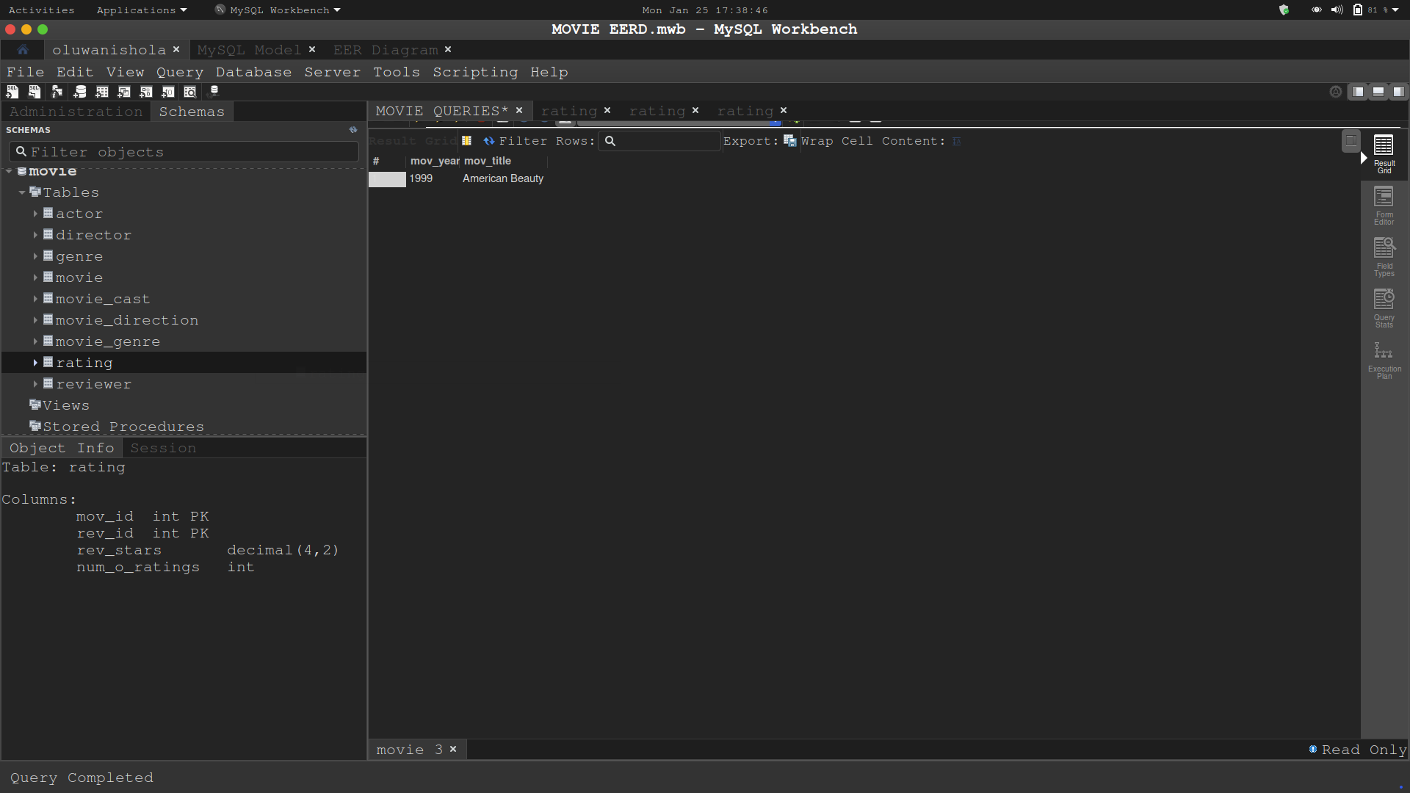

-- 3 Write a query in SQL to find the movie which was released in the year 1999

select mov_title, mov_year
from movie
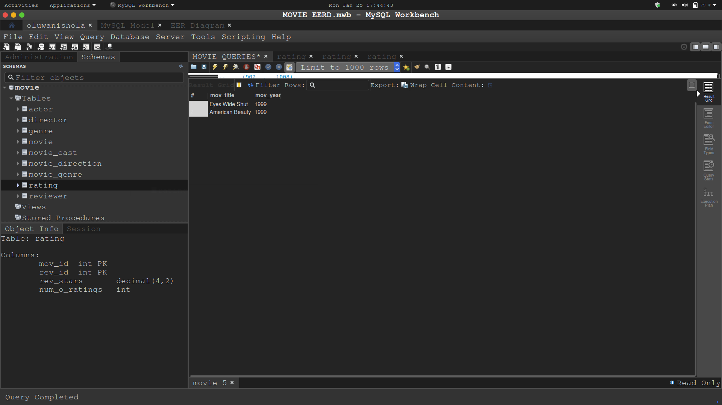
where mov_year = 1999;

-- 4 Write a query in SQL to find the movies which was released before 1998

select mov_title, mov_year
from movie
where mov_year < 1998;

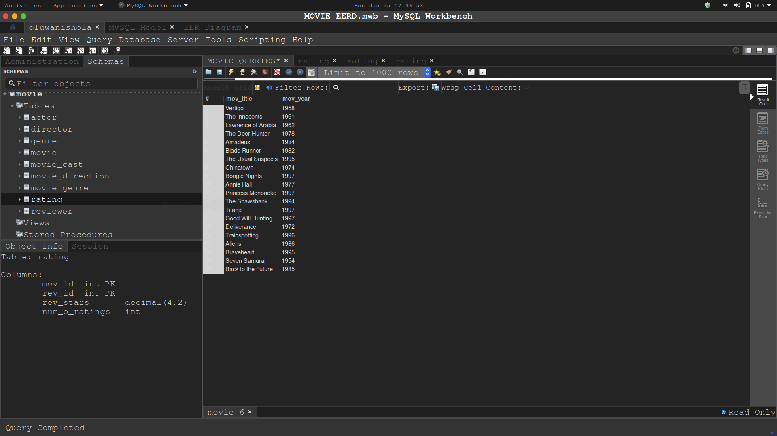

-- 5 Write a query in SQL to find the movie which was released in the year 1999

select mov_title, mov_year
from movie
where mov_year = 1999;

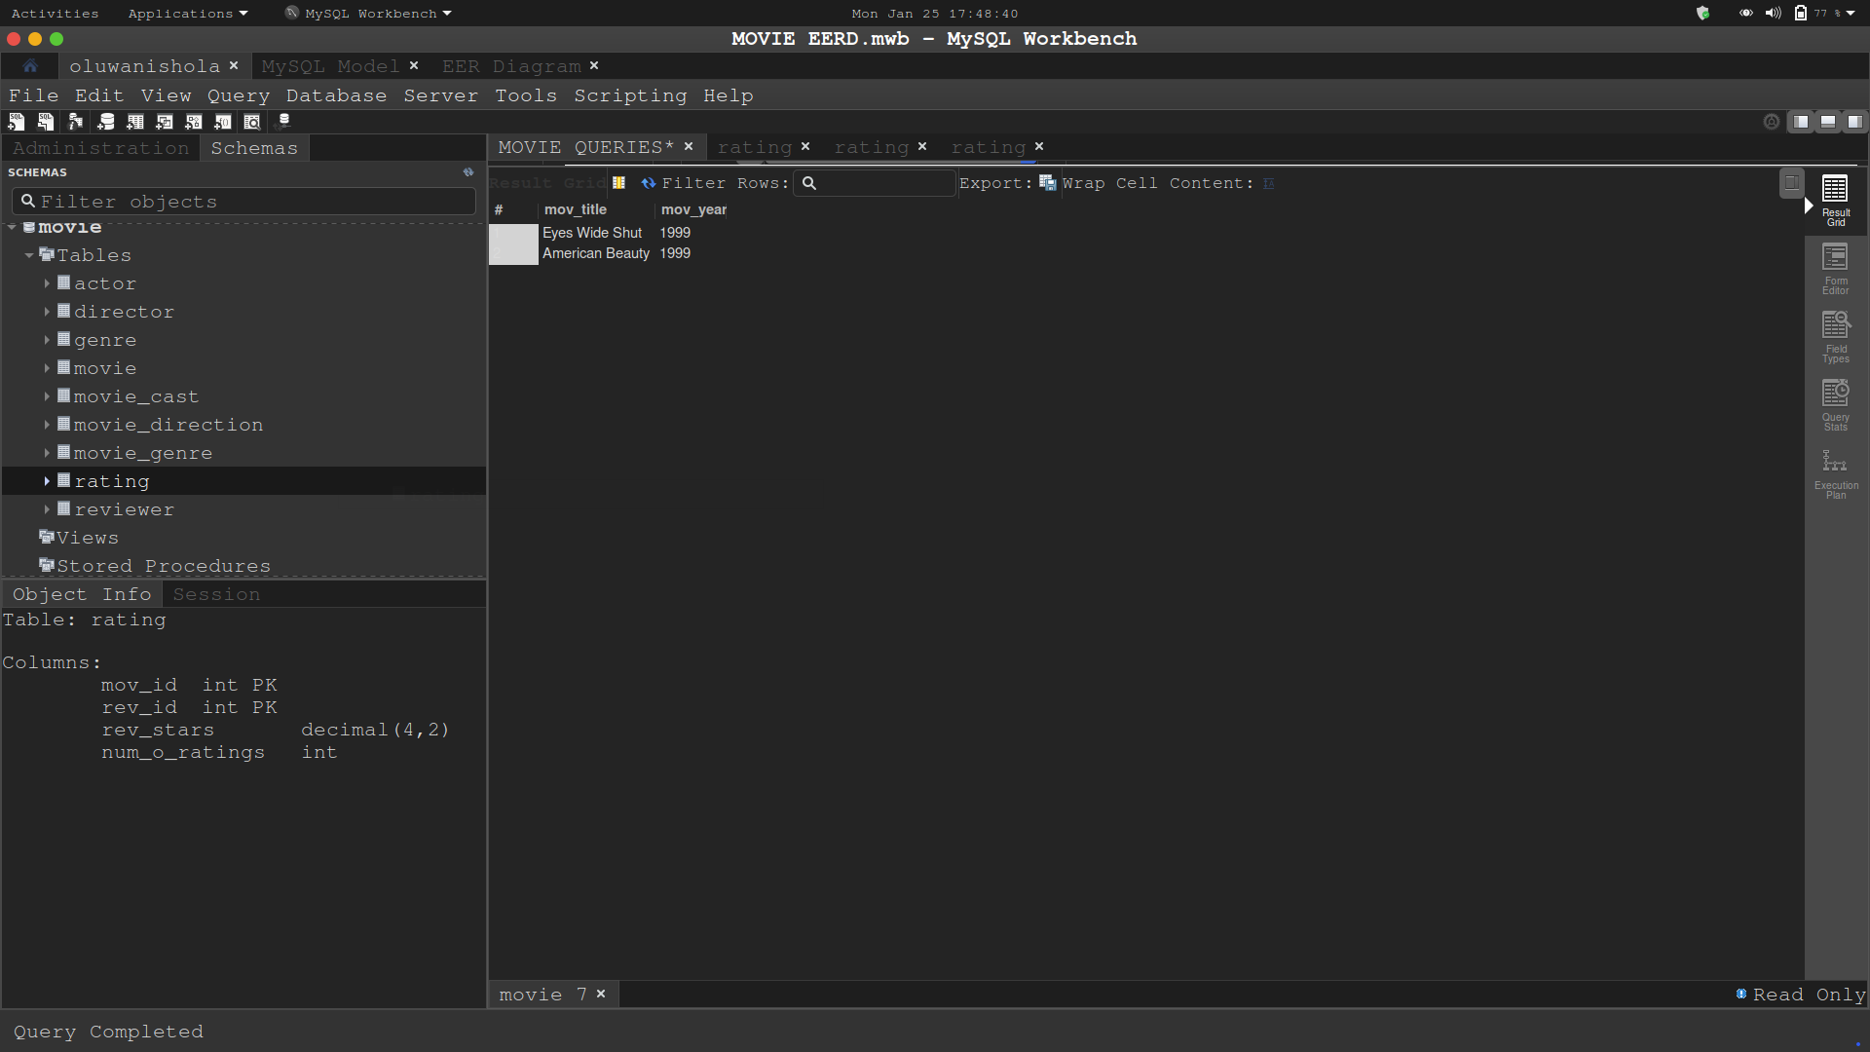

-- 6 Write a query in SQL to return the name of all reviewers and name of movies together in a single list

select rev_name, mov_title
from reviewer, movie;

select rev_name, mov_title
from reviewer
join movie
join rating
on rating.mov_id = movie.mov_id
and rating.rev_id = reviewer.rev_id;
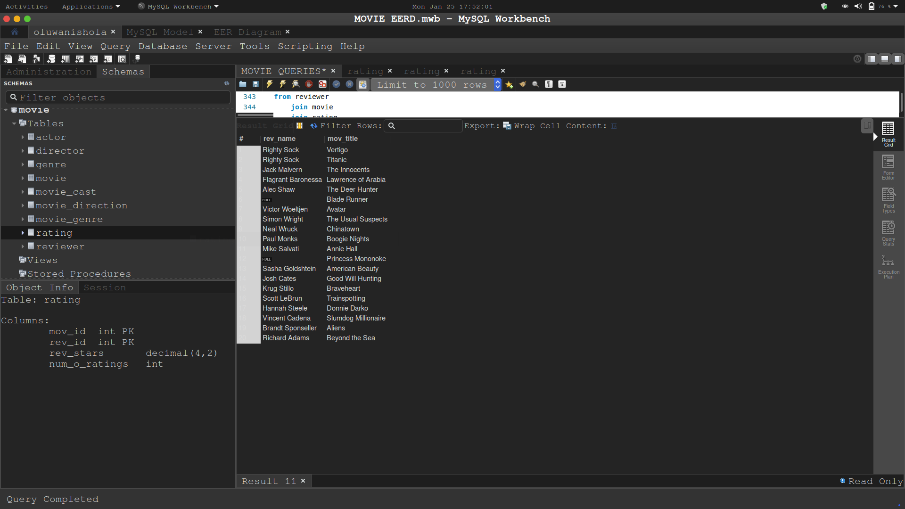

-- 7 Write a query in SQL to find the name of all reviewers who have rated 7 or more stars to their rating

select rev_name, rev_stars
from reviewer
join rating
on reviewer.rev_id = rating.rev_id
and rating.rev_stars >= 7;

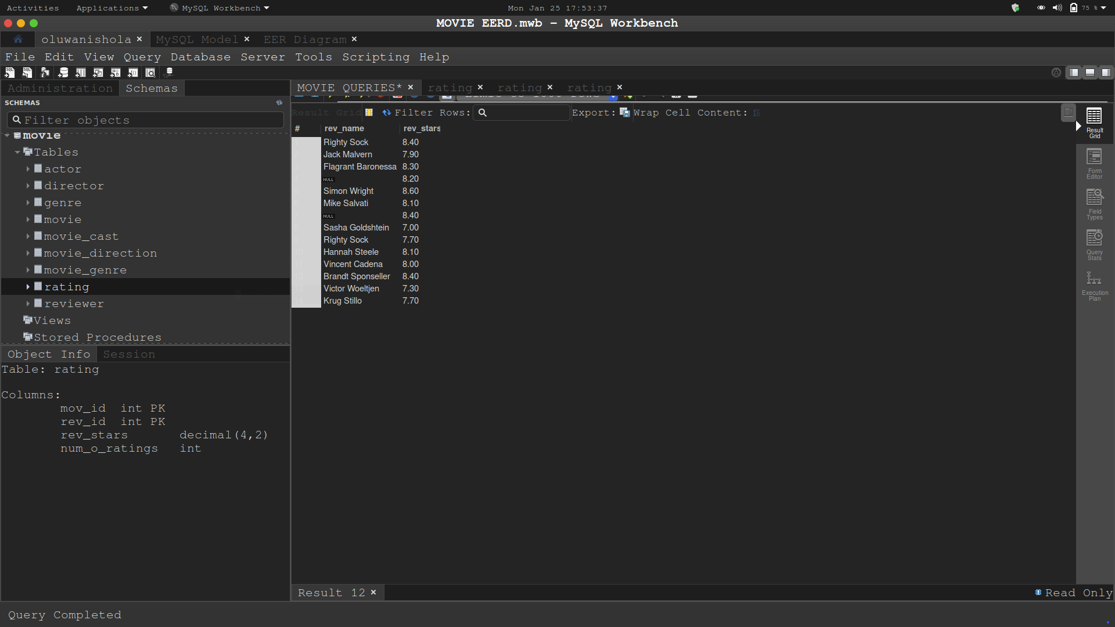

-- 8 Write a query in SQL to find the titles of all movies that have no ratings.

select mov_title, num_o_ratings
from movie join rating
on movie.mov_id = rating.mov_id
and num_o_ratings is null;

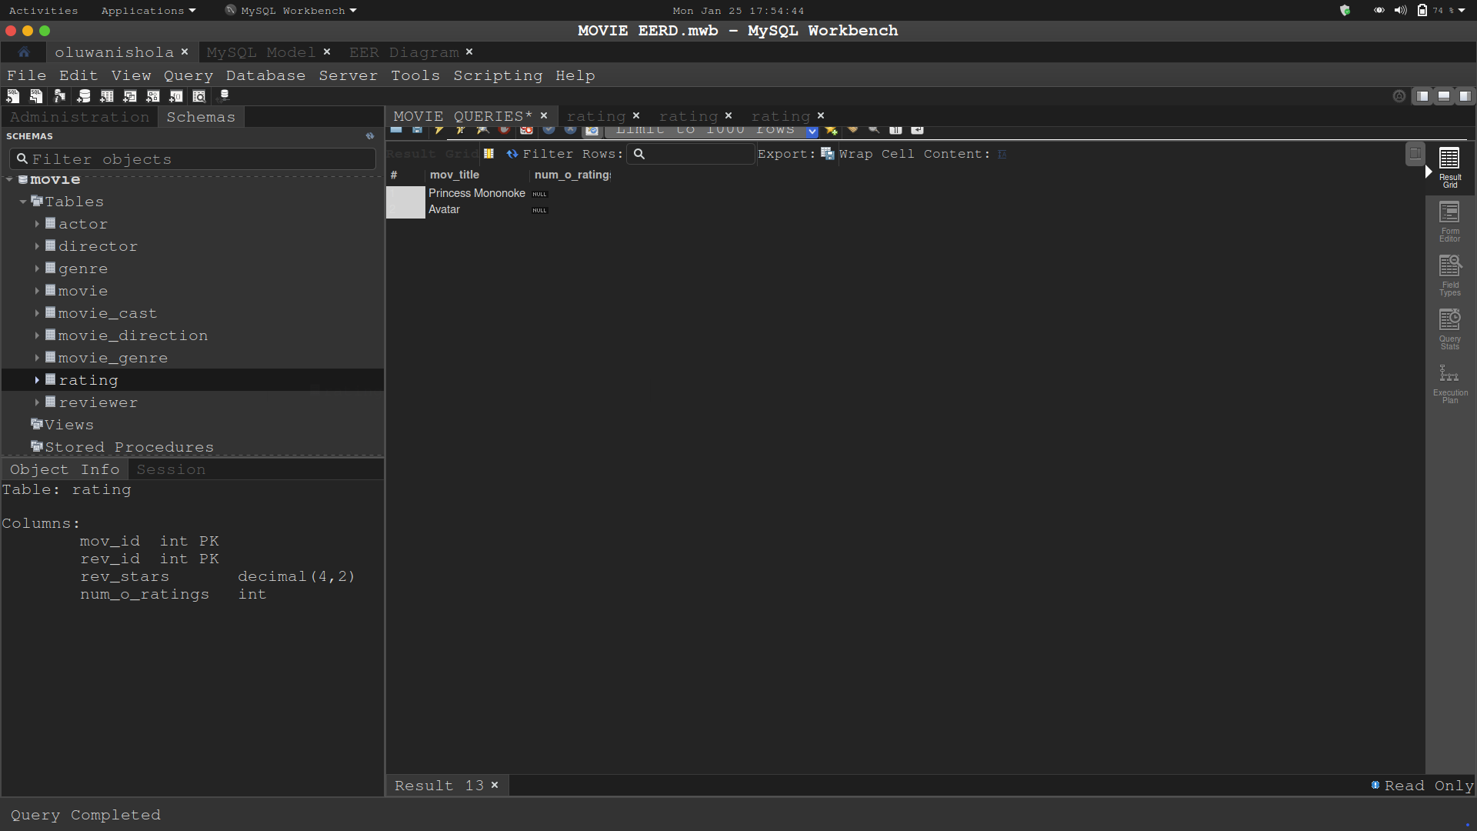

-- 9 Write a query in SQL to find the name of all reviewers who have rated their ratings with a NULL value
select rev_name, num_o_ratings
from reviewer
join rating
on reviewer.rev_id = rating.rev_id
and num_o_ratings is null;

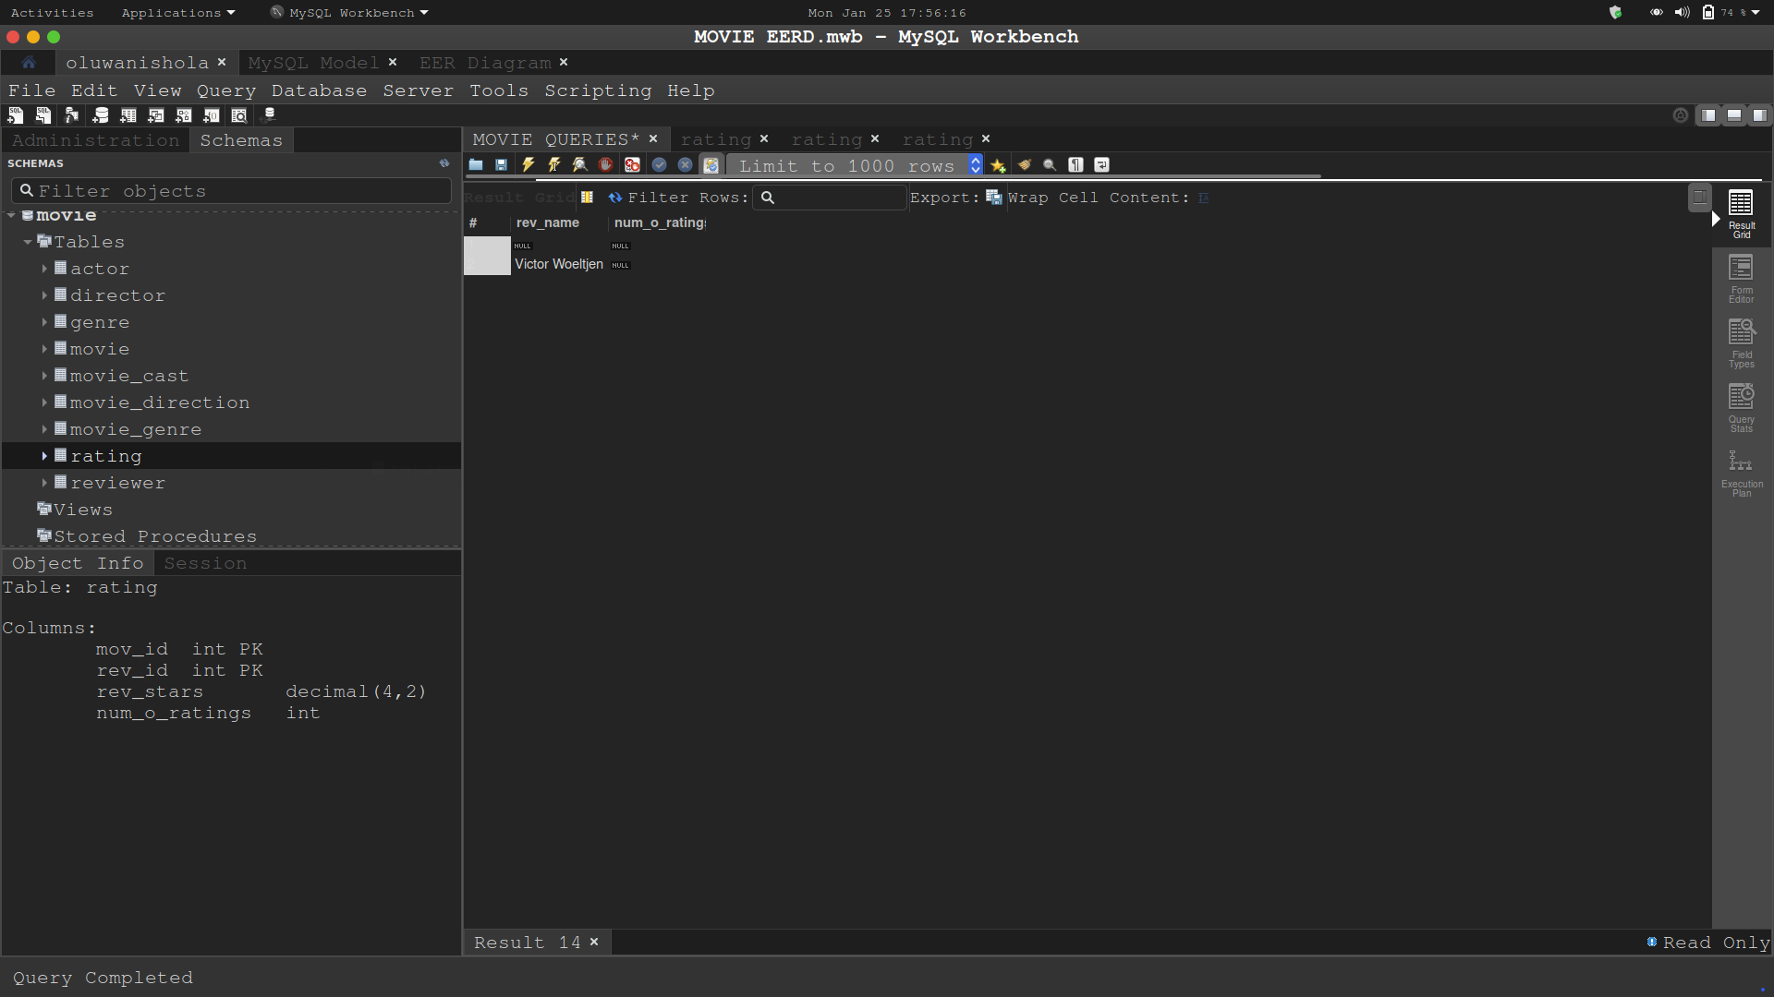

-- 10 Write a query in SQL to find the name of movie and director (first and last names) who directed a
-- movie that casted a role for 'Eyes Wide Shut'.

select mov_title, concat(dir_fname, ' ', dir_lname) as 'Director'
from movie
join director
join movie_direction
on movie.mov_id = movie_direction.mov_id
and director.dir_id = movie_direction.dir_id
and mov_title = 'Eyes Wide Shut';
